The Global Partnership for Development is one of the Millennium Development Goal that is targeted towards achieving a non-discriminatory trading and economic system that helps the less developed countries receive investments and gain information and communication with private sectors.
Our program addresses all the previously stated problems by allowing any seed company or sole proprietor touch base with investor or private sector that are loaded in the system; vice versa. The program works in such a way that a user will select between an Investor or a Seed Company. Depending on the specific user input, various questions will be asked and require an input from the user.
The following questions will be asked if the user were to select Investor:
- The name of the investor
- The surname of the investor
- The gender of the investor
- The age of the investor
- The email address of the investor
- The phone number of the investor
- The country the investor originates from
- The “seed” amount the investor is willing to invest into the company
- Various number of expertise
- A story about how the investor became so successful and what exactly the investor does.
The following questions will be asked if the user were to select Seed Company:
- The companies name
- The founder’s full name
- The email address for the company
- The phone number for the company
- The country the company originates from
- The net profit for the previous year and this year
- The revenue for the previous year and this year
- The “seed” amount the company is asking for
- The percentage of the company the investor will receive
- The target markets (expertise) for the company
- The companies story
The Investor user’s information will be input into an Investor.txt file in a specific format. The format is as follows:
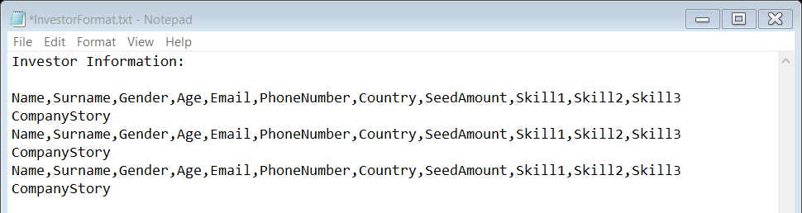
The Seed Company user’s information will be input into an SeedCompany.txt file in a specific format. The format is as follows:
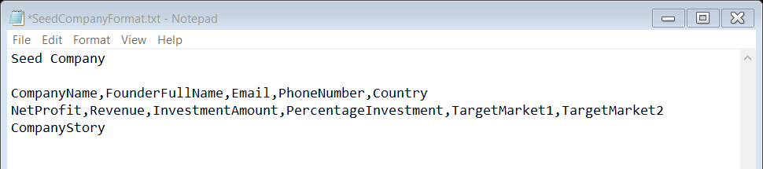

After the user has input the information, they must click the button Display Possibilities this will then display, in a text box, all the possible investors (if the user is a Seed Company) or all the possible Seed Companies (if the user is an Investor).
The criteria that seed companies need to display for an investor is as followed:
- If the seed company have gone through the process of being added to the SeedCompany.txt text file.
- If at least one target market for the seed company matches with at least one expertise of the investor
- If the investment amount for the seed company is within the seed amount for the investor.

This program aims to allow companies world-wide find investors willing to invest an amount for a specific percentage of their company. The seed company will be able to read the story of multiple investors, as well as, receive their contact details. The process of finding investor or seed companies becomes a smoother process, as well as, less time consuming. Investors may want to use the program as the process is faster and they receive all the necessary information to make a call to invest or not to invest. The program allows investors to search for seed companies world-wide that suit their needs and by displaying all the possible seed companies it allows for less developed countries have a possible investment from a more developed country. It allows for the seed companies to learn new skills, grow their contacts and to have the opportunity to become a larger company that can employ more people and help achieve a global partnership for development.

